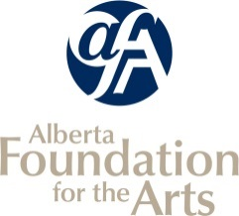
Operational Funding
INCLUDE ONLY ACTIVITIES PRODUCED OR PRESENTED BY YOUR ORGANIZATION AS OUTLINED IN THE GUIDELINES.
Final Report Attachments

Listing of Completed Arts Activities

Organization Name: |  | Reporting Period:

* Your reporting period can correspond to your most recent board-approved financial statements.
e.g. If your FISCAL year-end is December 31, your activities will have occurred between January 1 and December 31 of that year.
OR list completed activities corresponding to your last CSO application. Your TOTALS must match your Statistical Report (Arts Activities section) page in your Final Report in GATE

Date From  (dd/mm/yy) | Date To  (dd/mm/yy) | Name of Self-Produced Public Performance, Event, Tour, Workshop, Class or Exhibition: | Venue: | City/Town: | Artists Hired  (Performers, Instructors, Exhibitors): | Fees Paid to Artists: | Paid Attendance: | Unpaid Attendance: | Event/Activity Revenue:
 |  | - Public Performances and/or Literary Readings presented by your organization  - Exhibitions organized and/or curated by your organization  - Film/Video/Media screenings programmed by your organization  NOTE: If your arts activity was affected by Covid-19 restrictions, please insert ANY other activity that you have carried out in your previous fiscal year (e.g. AGM meetings, virtual workshops, rehearsals). |  |  | - Number of artists your organization paid artist fees and/or salaries for this activity  - Include performers, exhibitors, or artists who were paid distribution fees |  | TOTAL paid attendance (estimate if necessary) | TOTAL unpaid attendance (estimate if necessary)
 |  |  |  | Total

