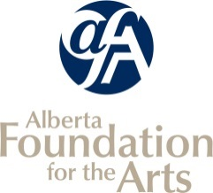
Community Performing Arts Organizations
INCLUDE ONLY ACTIVITIES PRODUCED OR PRESENTED BY YOUR ORGANIZATION AS OUTLINED IN THE CPAO GUIDELINES.
Final Report Attachments

Listing of Arts Activities

Organization Name: |  | Reporting Period:

* Your reporting period can correspond to your most recent board-approved financial statements. If your FISCAL year-end is December 31, your activities will have occurred between January 1 and December 31 of that year.
OR list completed activities corresponding to your last CPAO application.

Date From  (dd/mm/yy) | Date To  (dd/mm/yy) | Name and Type of Self-Produced Public Performance, Event, Tour, Workshop, Class or Exhibition | Venue | City/Town | Number of Artists Hired  (Performers, Instructors, Exhibitors) | Fees Paid to Artists | Paid Attendance | Unpaid Attendance | Event/Activity Revenue
 |  | - Public performances and/or literary readings presented by your organization  - Exhibitions organized and/or curated by your organization  - Film/video/media screenings programmed by your organization |  |  | - Number of artists you paid a fee or salary to for this activity  (include performers, exhibitors, or artists who were paid distribution fees) |  | TOTAL number of paid attendees (estimate if necessary) | TOTAL number of unpaid attendees (estimate if necessary) | Includes ticket sales, concession, donations, etc.
 |  |  |  |  |  | $ |  |  | $
 |  |  |  | Total |  | $ |  |  | $

