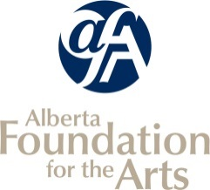
Community Performing Arts Organizations
INCLUDE ONLY ACTIVITIES PRODUCED OR PRESENTED BY YOUR ORGANIZATION AS OUTLINED IN THE CPAO GUIDELINES.
Final Report Attachments

Listing of Completed Arts Activities

Organization Name: |  | Reporting Period:

* Your reporting period can correspond to your most recent board-approved financial statements.
e.g. If your FISCAL year-end is December 31, your activities will have occurred between January 1 and December 31 of that year.
OR list completed activities corresponding to your last CPAO application. Your TOTALS must match your Statistical Report (Arts Activities section) page in your Final Report in GATE

Date From  (dd/mm/yy) | Date To  (dd/mm/yy) | Name and Type of Self-created and Self-Produced Public Performing Arts Activity carried out in your previous fiscal year | Venue | City/Town | Number of Artists Hired  (Performers, Instructors) | Fees Paid to Artists | Paid Attendance | Unpaid Attendance | Event/Activity Revenue
 |  | - If your performing arts activity was affected by Covid-19 restrictions, please insert ANY other activity that you have carried out in your previous fiscal year (e.g. AGM meetings, virtual rehearsals). |  |  | - TOTAL number of artists you paid a fee or salary to for this activity (include performers, or artists who were paid distribution fees) |  | TOTAL number of paid attendees (estimate if necessary) | TOTAL number of unpaid attendees (estimate if necessary) | Includes ticket sales, concession, donations, etc.
 |  |  |  |  |  | $ |  |  | $
 |  |  |  | Total |  | $ |  |  | $

