Completing an Applicant Profile in the GATE System

Follow these instructions to complete an Applicant Profile. You must do this before you can submit an application to the Public Art Commission Program.

Overview:

- The Applicant Profile includes general contact and organization information that is stored in the online GATE system.
- Once this profile is complete, you will not need to re-enter address, contact information, etc. for future applications.

Instructions:

- Log into the system using the user ID and password provided. The system will ask you to change your password; please re-set it to something you will remember the next time you log in. If you forget your password, please e-mail registrationAFA@gov.ab.ca to have it reset.

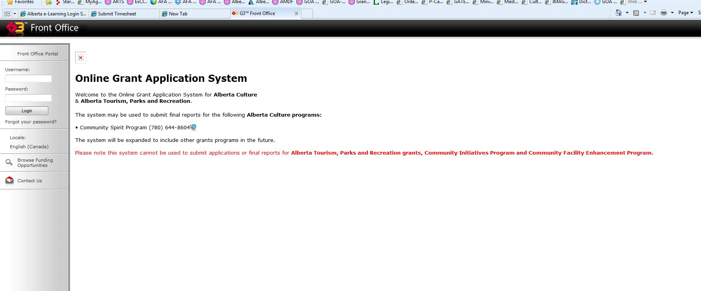Figure 1 – Logging in to the system

- Click on the “Browse Funding Opportunities” link on the left hand menu bar to locate the Public Art Commission funding opportunity.

Figure 2 – Front Office Portal - “Browse Funding Opportunities”

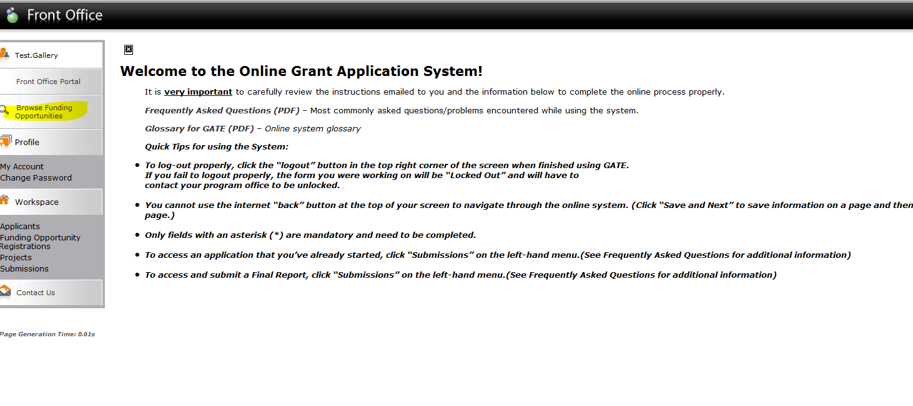

- Find the Public Art Commission Project program in the list of funding opportunities. Use the search function if you need to. Click the magnifying glass icon under the “View” column next to Public Art Commission Project.

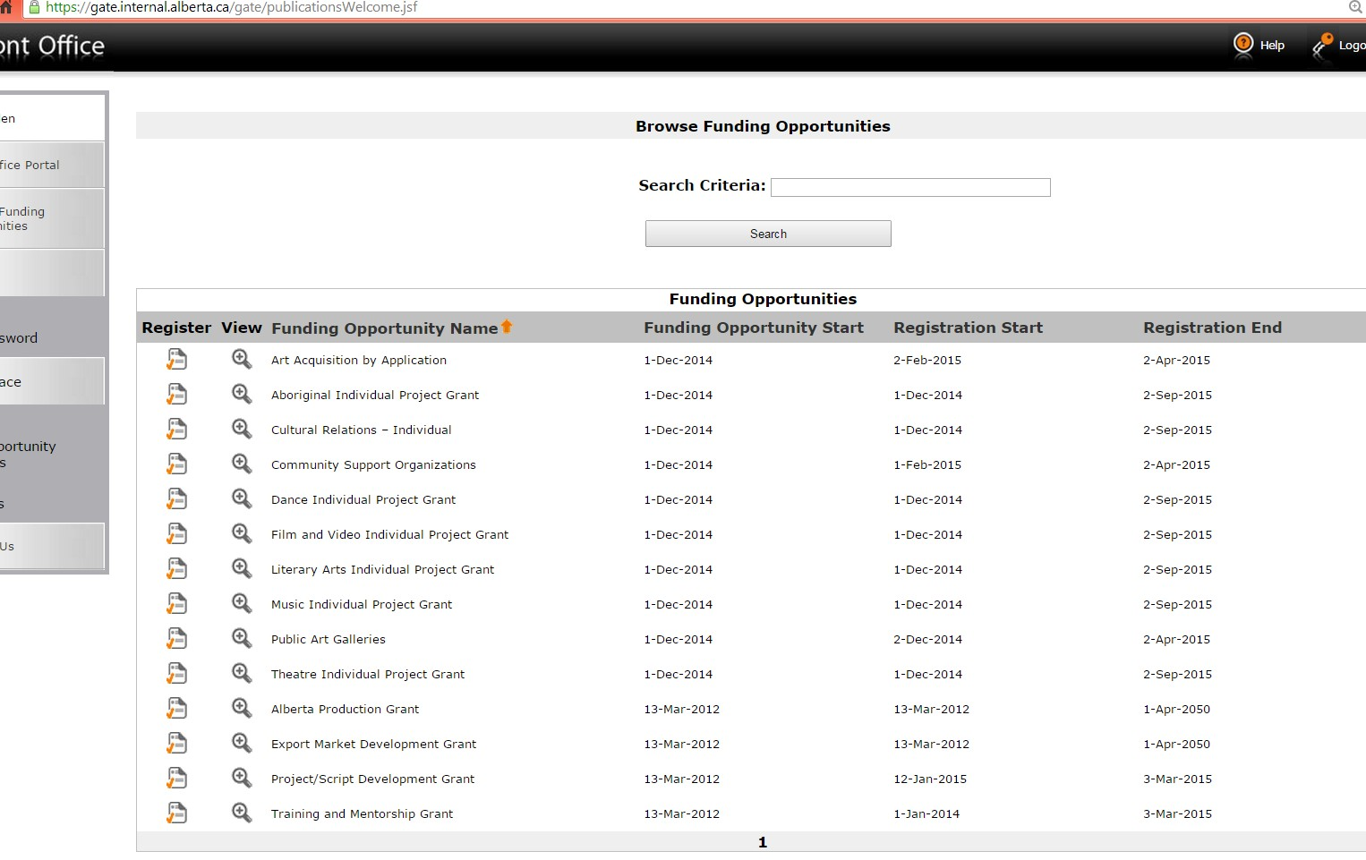Figure 3 – Searching for the program you would like to apply for

- The program information page will appear. Click the “Apply Now” button at the bottom of this page to open the registration wizard.

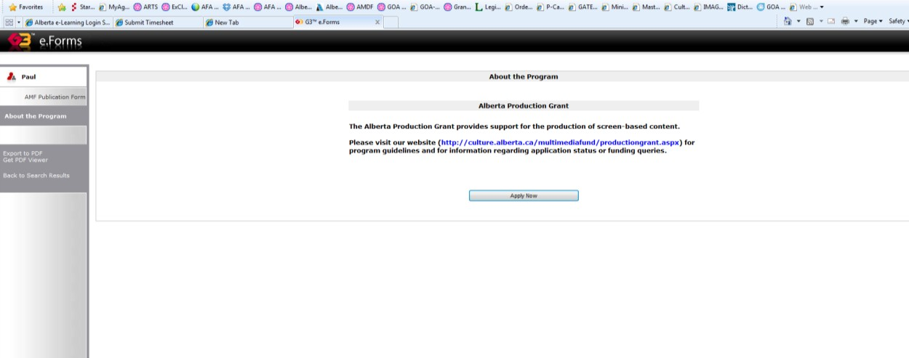Figure 4 – Program information page

- On the Applicant Details page, select your name from the drop down list at the top of the page to complete the Applicant Profile. DO NOT enter anything in the fields at the bottom of the page— you will create a duplicate Applicant Profile.

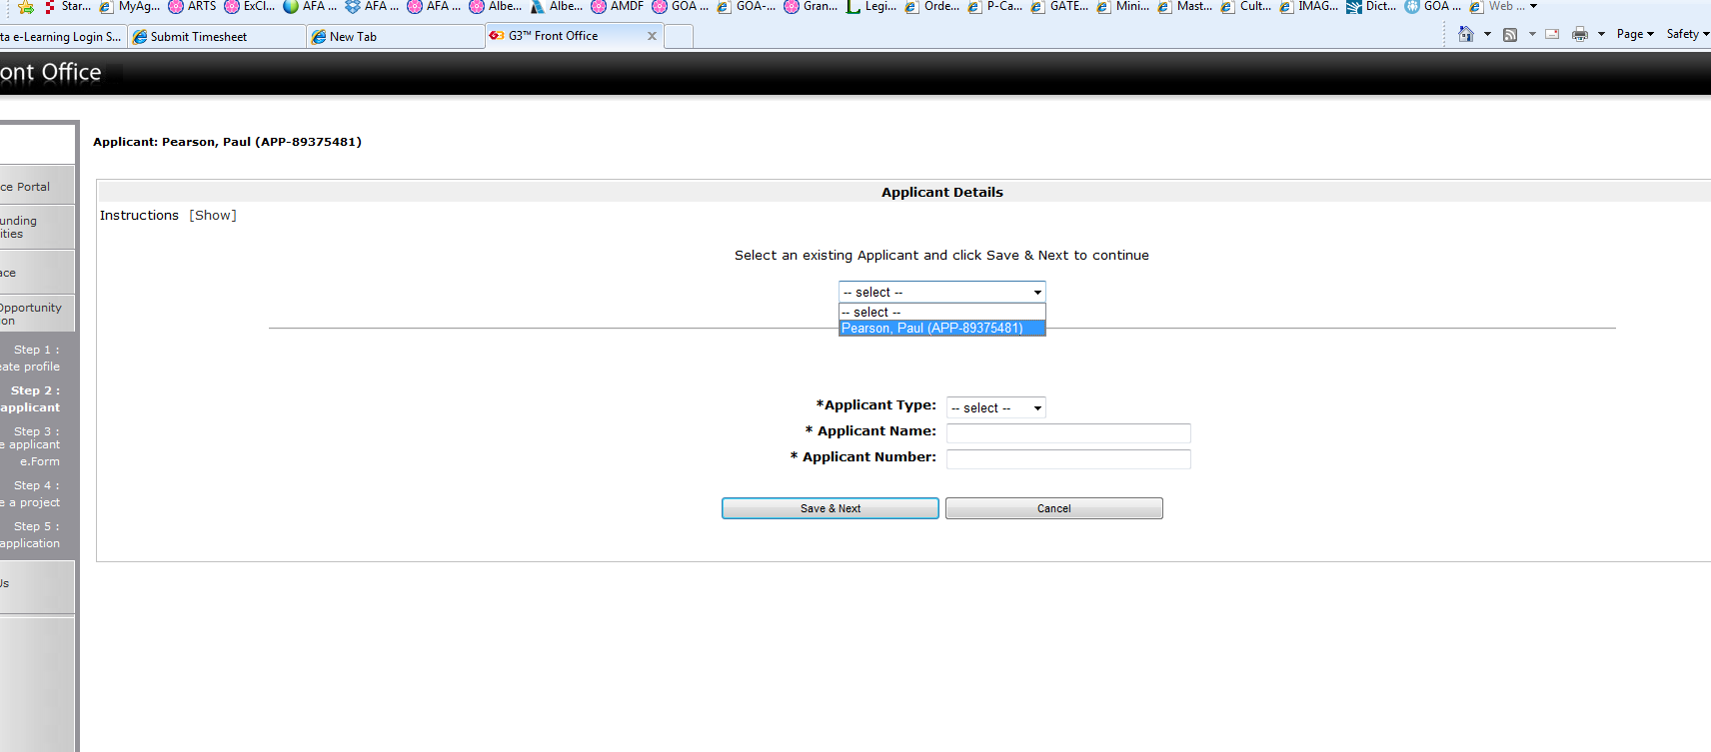Figure 5 - Applicant Details page

- Click “Save and Next”.

7. If you are an individual applicant, choose “Organization, “Save and Next”. You will be shown a screen where you enter your full legal name. Enter your name and choose “Save and Next.

Non-profits or charitable organizations should choose “Organization Not-for Profit”, “Charitable Organization” or other applicable Applicant Type.

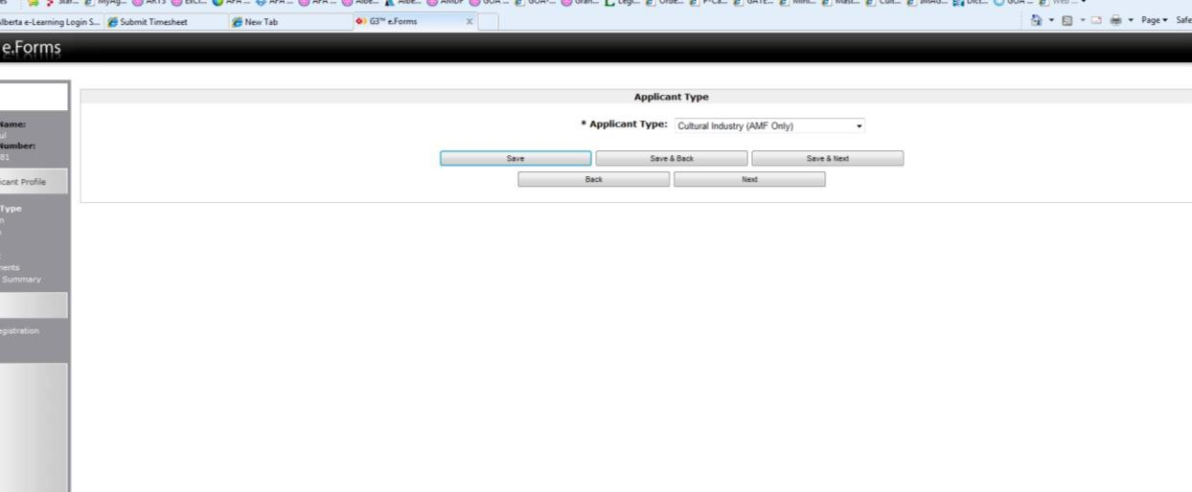Figure 6 – Applicant Type field

- Click “Save and Next.”

- For commercial galleries, non-profits or other organizations, you will be asked about your incorporation status. If your organization or business is registered with Service Alberta please choose the “Yes” button. If your organization is registered charity, please also choose ” Yes” in this window.

Figure 7 –Organizations field
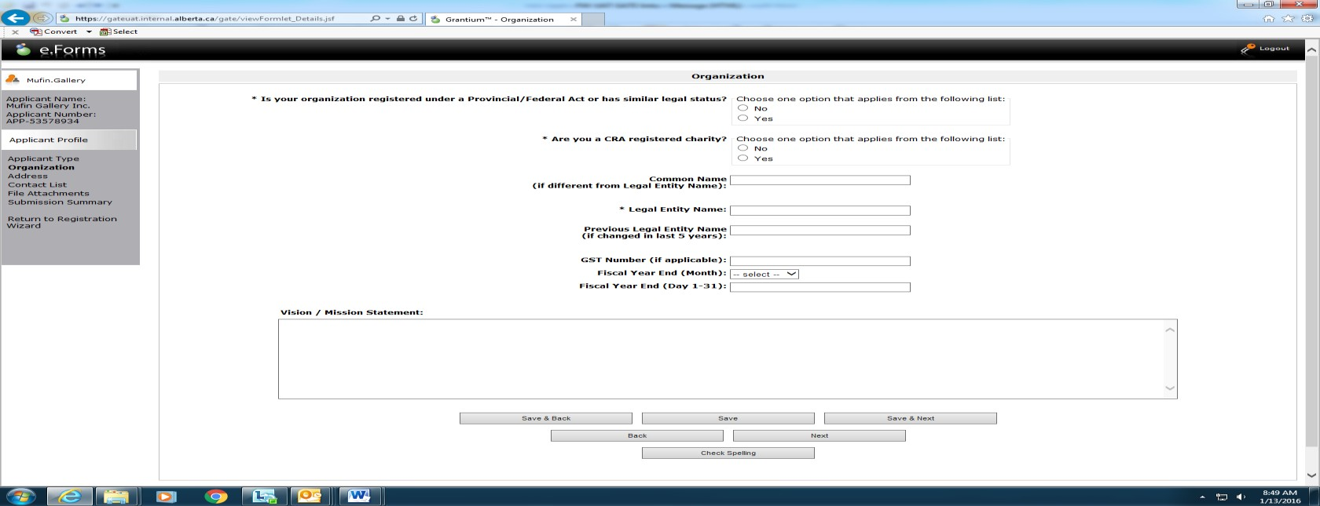

- Please enter your legal business name here (ex. 123456 Alberta Inc.). Information entered into the other fields is encouraged but not required.

Figure 8 –Organization field

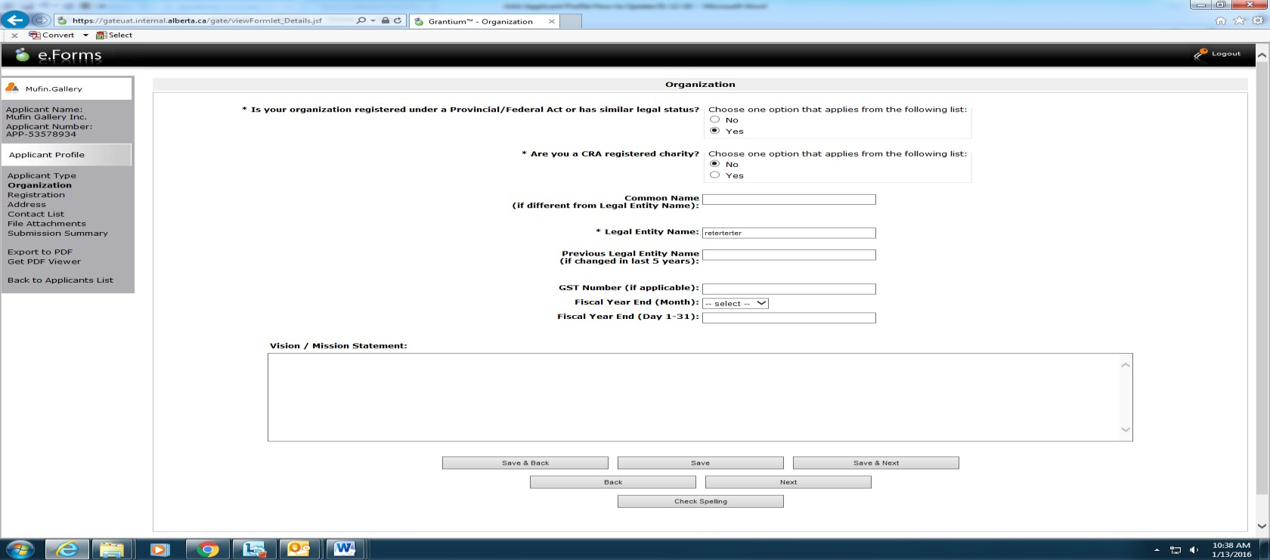

- If your organization or business is registered in Alberta, a registration window will appear. Please choose how you are registered. If you are a commercial gallery, please choose “Not Registered” from the drop down menu. Other organizations should choose the appropriate registration type from the drop down list.

Figure 9 – Registration field

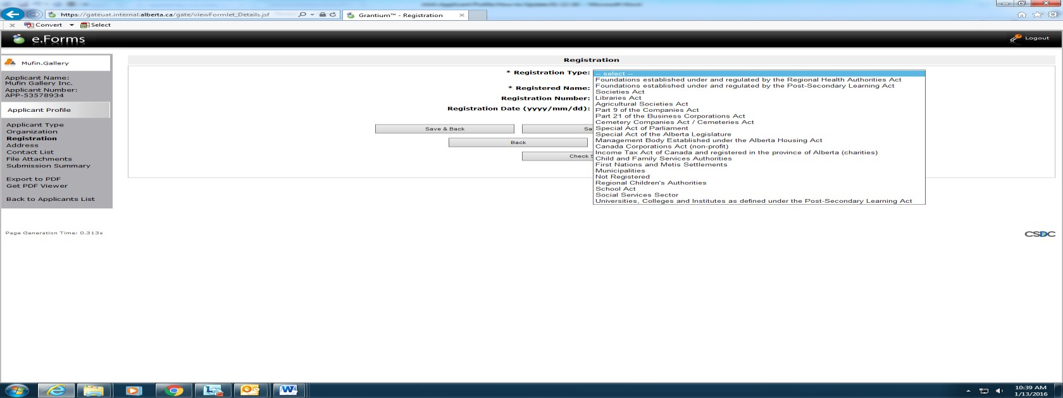

- Please enter your Incorporation Number, Corporate Registration Number or Charitable Tax Number under “Registration Number” and enter the date you were registered.

Figure 10 – Registration field part 2

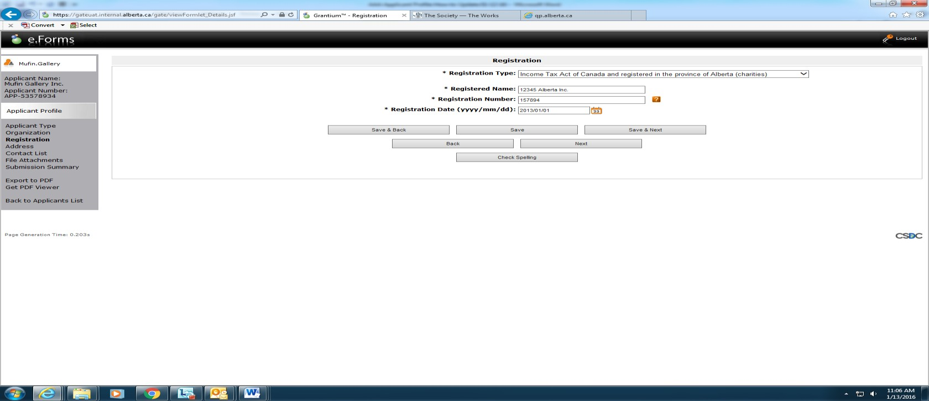

- Fill in your address. Remember that you are still setting up your Applicant Profile at this stage. If you change your address for subsequent applications, you will need to return to your Applicant Profile and update the account: information does not transfer automatically from the Program Application to the Applicant Profile.

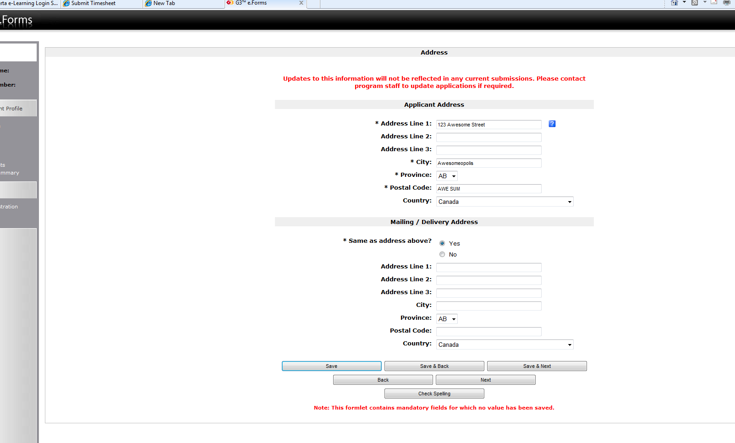Figure 11 – Applicant Address

- If your mailing address is different from the address indicated in the “Applicant Address” section, complete the “Mailing / Delivery Address” section as well.

- Click “Save and Next.”

- This page requires you to add contacts: you must enter at least one contact. Usually it will be yourself, though some applicants may elect to use others as alternate points of contact.

- Click the orange “plus” icon on the upper left hand side of the page to create a primary contact.

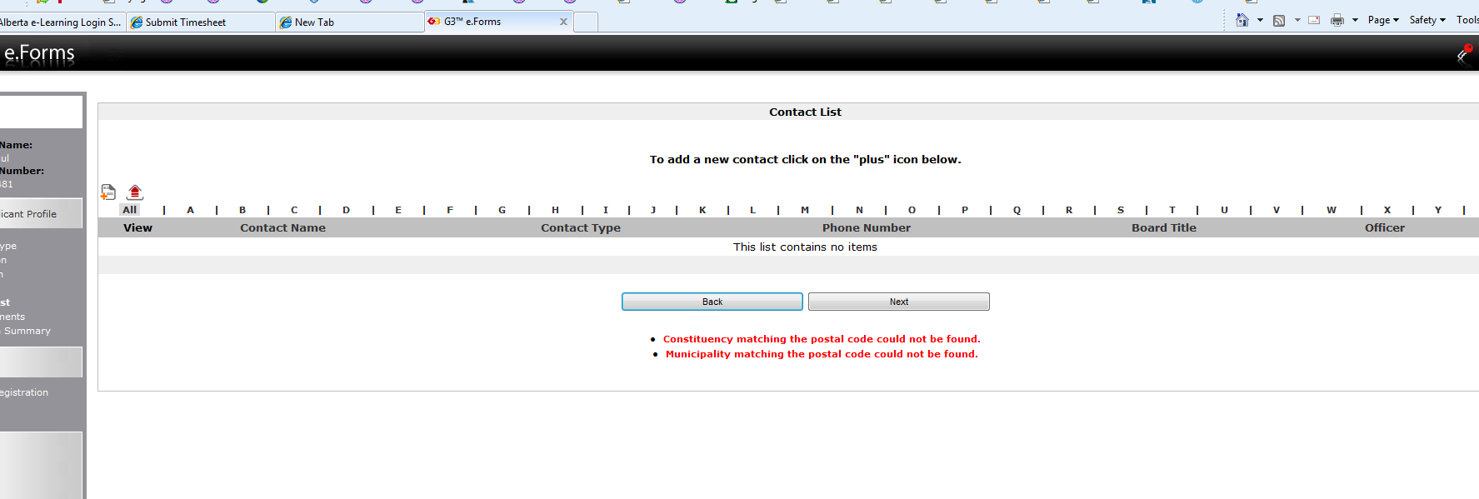Figure 12 – Contact List page

- On the page that opens, record your information. In the “Contact Type” drop down field, select “Primary Contact.”

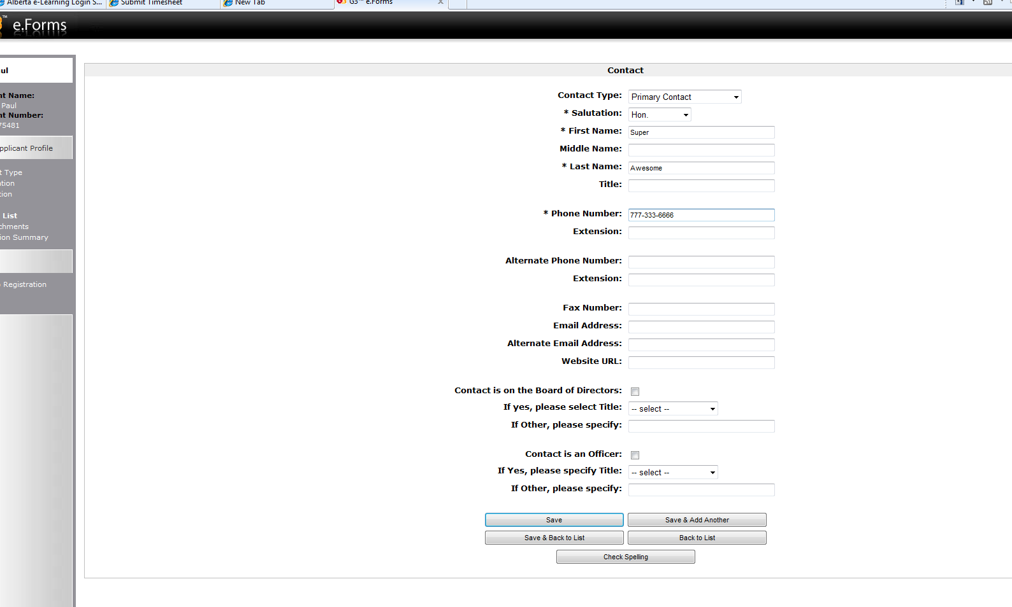Figure 13 – Entering Contact information

- Enter the relevant information for this individual. Only the fields marked with an asterisk are mandatory to complete.

- If you want to add an alternate contact, click “Save and Add Another” when you have entered your information and continue with step 20.

- If you want to only enter one contact, click “Save and Back” when you’re done and skip to step 23.

- On the next page, enter the information for the alternate contact. In the “Contact Type” drop down field, select “Authorized Representative.”

- Enter the relevant information for this individual. Only the fields marked with an asterisk are mandatory to complete.

26. When finished, scroll down and click “Save and Back to List”.

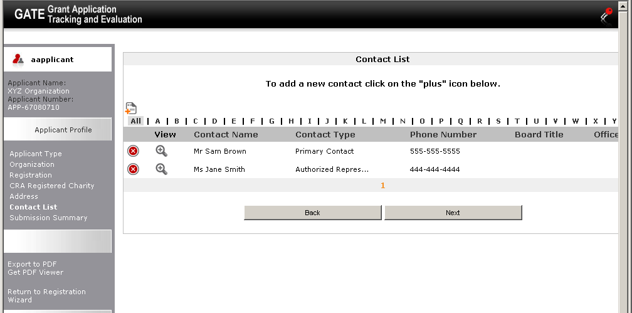Figure 14 – Completed Contact List

- You will now see the completed contact list. (Additional contacts may be added in the future.)

- Click “Next.”

- This page allows you to upload supporting documents. Nothing is required at this stage. Your best option is simply to click “Next.”

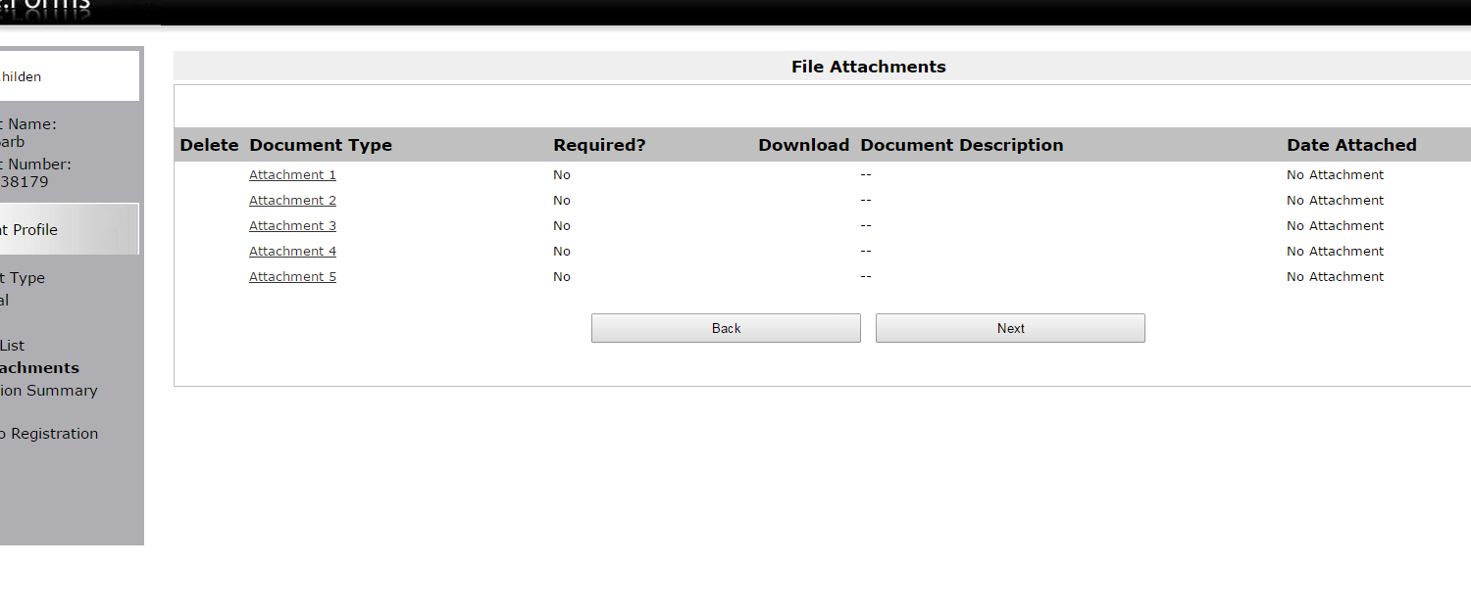Figure 15 – File Attachments

- The Applicant Profile is almost ready! This page allows you to formally “Complete” your registration. You should see a list of bright green checkmarks. If any information is missing, you will see a big red X next to the item. (Click on the name of the page that needs to be completed in order to return to it.)
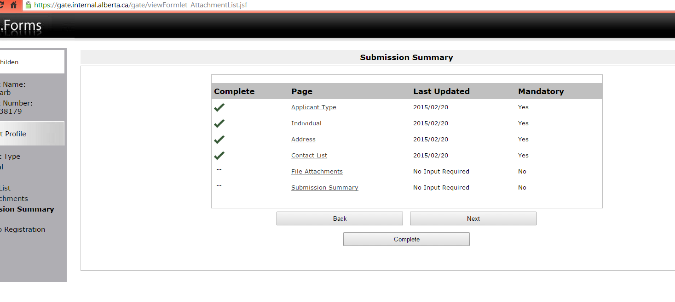Figure 16 – Submission Summary page

- Click the “Complete” button. Do not click the “Next” button. That will take you back to the first screen.

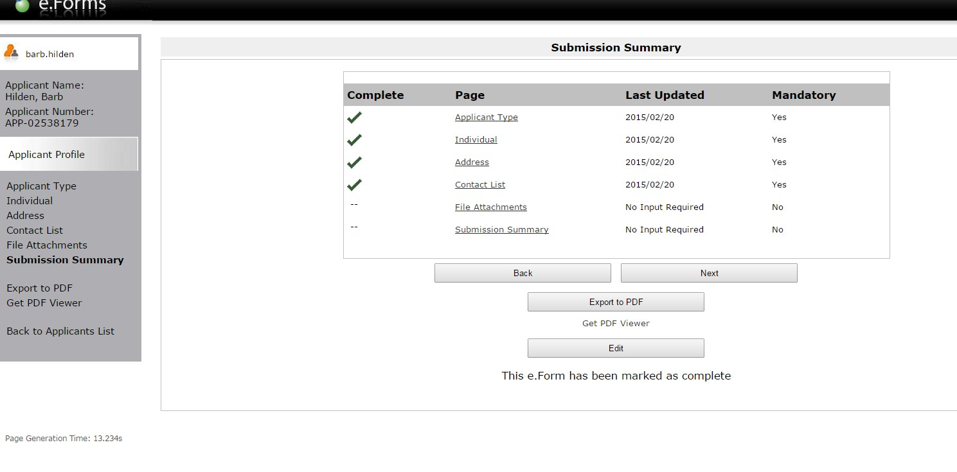Figure 17 – Completed Applicant Profile

- An “Edit” button should now be visible. Underneath, it will say “This e.Form has been marked as complete.” (NOTE: You must click this “Edit” button if you want to make changes to the Applicant Profile in the future. If you do, click “Complete” again to update and close the Profile.)

- Your Applicant Profile is ready! You may now begin the Public Art Commission Program application. Click “Return to Registration Wizard” from the bottom of the left hand menu, and open the second document sent to you in the GATE registration e-mail.

